**Scorecard Batch Process**

1. Download the jar file from <https://github.com/siteadmin/scorecard-batch/tree/master/artifacts>
2. Please create the config file scorecard-batch.config with the following properties:

* scorecardBatch.ccdaFileLocation=/var/opt/scorecard/ccdaFiles
* scorecardBatch.outputFolderLocation=
* scorecardBatch.scorecardUrl=https://devccda.sitenv.org/scorecard/ccdascorecardservice2

A sample config file can be found at <https://github.com/siteadmin/scorecard-batch/blob/master/src/main/resources/scorecard-batch.config>

* **scorecardBatch.ccdaFileLocation** - Folder location where all the CCDAs are placed for scoring. This is a mandatory property.
* **scorecardBatch.outputFolderLocation** - Folder location to save the response files. If this is not specified a default folder scorecardBatchOutput is created in root folder and are saved to this location.
* **scorecardBatch.scorecardUrl** - Specify the scorecard service end point for response. If this is not specified, the batch process will default to the Scorecard Production Server Endpoint.

1. **Open Command Prompt and Run As Administrator**. Navigate to the location where the jar file is placed. For example, the jar file is placed under C:\Projects.

Execute the following command.

java -DconfigFileLocation="C:/var/opt/scorecard/scorecard-batch.config" -jar scorecard-batch.jar

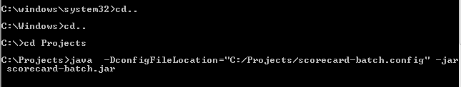

1. The response files will be created in the folder specified in the location specified in the **scorecardBatch.outputFolderLocation** property of the config file.

